E1 Elimination
(Hoffman Product)
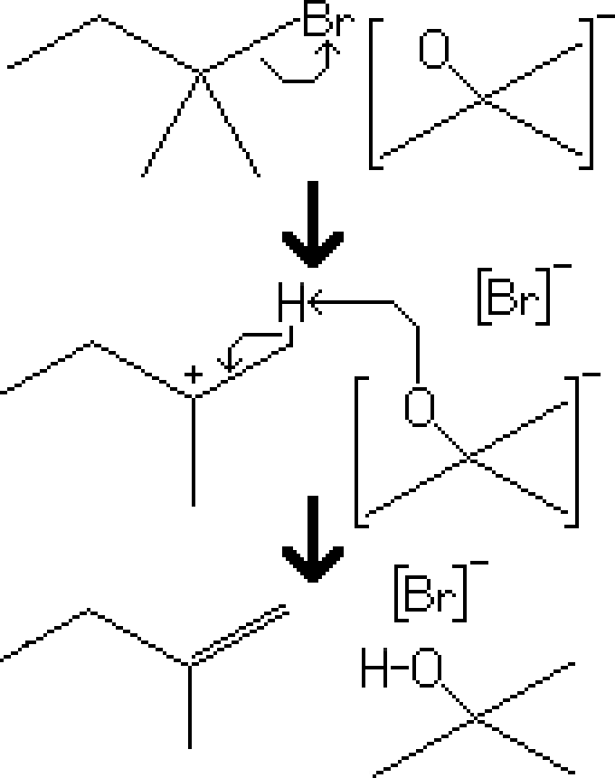
Reactants – Tertiary Alkyl Halide, t-BuOK
Products – Alkene (Hoffman), t-BuOH, Br⁻
Electron Movement
- E1 Reaction – The alkyl halide leaves the molecule, creating a carbocation intermediate. The tert-butoxide attacks a proton on the least branched beta carbon, and the electrons are distributed to the carbon-carbon bond, resulting in an alkene

Notes
- Note that this reaction results in a 4:1 ratio of the hoffman product over the zaitsev product.
- Because tert-butoxide is sterically hindered, it's more likely to take the proton of the least branched beta carbon. If it were less sterically hindered, then it would be more likely to take the proton of the more branched beta carbon, resulting in the zaitsev product.

